Do big fecund fish contribute relatively more to population productivity when they are scarce?

Authors

Nis, Mikael, Ole, Jane, Anna, Ken?

# Introduction

To have continued sustainable exploitation of marine fish stocks there needs to be a thorough assessment of impact of changing the size and age structure of a population. Fishing changes the age structure of populations by selectively removing older (and larger) fish both due to the inherent gear selectivity, but also through the accumulated mortality older fish experience (Barnett et al., 2017). However, the consequence this has on sustainable management of fish is not

It has been argued in the literature that maternal effects (or sometimes called ‘big old fat female fecund fish (BOFFFS)’ may provide an increased number (and viability) of eggs per kg of spawning fish, in comparison to their younger and smaller specimen (Barneche et al., 2018; Field et al., 2008), and may therefore lead to erroneous estimates of population productivity and thus have management incorrectly calculate reference points (Marshall et al., 2021). In particular, it has been argued that egg production of females should scale hyperallometrically rather than isometrically with individual weight to get the proper estimate of egg production per spawner. However, these analyses often fail to include 1) demographic effects, where older fish only comprise a small fraction of the total spawning biomass (Andersen et al., 2019), 2) external factors that influence spawning success, such as ambient temperature or egg predation, 3) recruitment to a stock does not occur at the egg stage, and a common assumption is that density dependence regulates stock abundance between the time when eggs are spawned and recruited into the population.

We constructed a range of models to test the impact of these three factors, and in particular identify which life histories are susceptible to erroneous assessment due to maternal effects. In particular, we look at the impact of density dependence, stochastic variation, and reference points. How maternal effects management of stocks is therefore unclear in the light of these caveats. Using management strategy evaluation (MSE) we test maternal effects on three simulated life history types, representing small fast growing species with high recruitment variability (e.g,, similar to sardine), a medium sizes species with moderate recruitment variability (e.g., haddock), and a larger species with low recruitment variability and stronger relationship between recruitment and spawning biomass (e.g., Atlantic cod).

# Methods

Standard age based model

We model egg production as an isometric function of spawner weight

$$E_{iso,a}=α_{iso}N_{a}$$

Where E is the egg production and $α$ is a parameter determining the number of eggs per individual spawner, $N$, and *a* denotes the age. This formulation also ensures that the intercept is at 0.

In hyperallometric cases the egg production is modeled as

$$E_{hyper,a}=α_{hyper}N_{a}^{β}$$

Where $α$ and $β$ are scaling parameters.

These two formulations will lead to two unique fits to data, where the hyperallometric fit will lead to relatively higher egg production at large sizes, but the isometric formulation will lead to a little higher egg production at small sizes. This formulation is a better relative representation of what the scaling would look like in comparison with (Barneche et al., 2018) which automatically assumed that $α_{iso}$ and $α_{hyper}$ should be the same, and only $β$ should change. An example of this fit is presented in figure 1 for cod (Gadus morhua) and Northern Anchovy (Engraulis modrax), data from Barneche et al (2018).

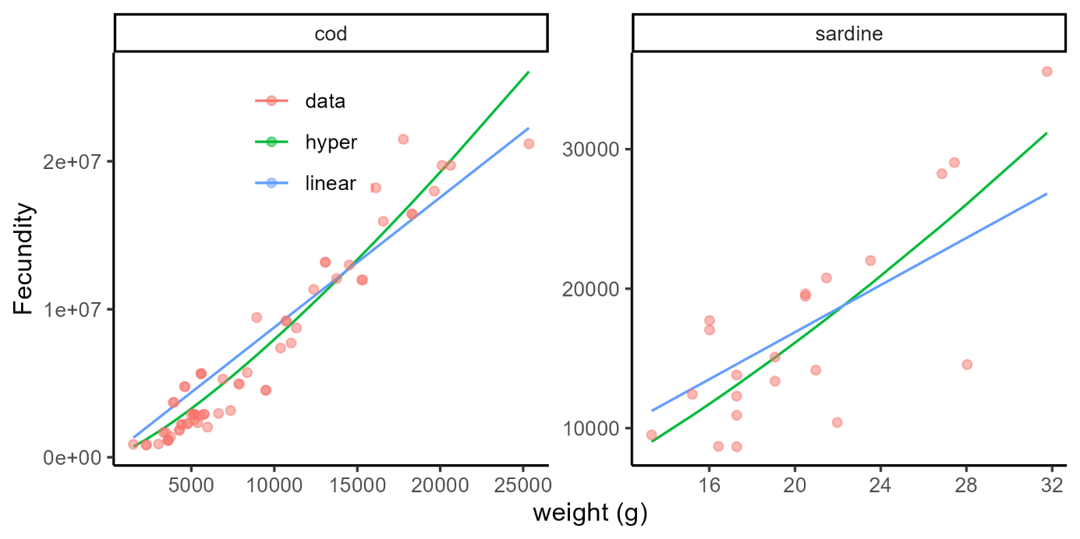

Figure 1: Egg production (fecundity) as a function of weight for cod and sardine. red points denote data, green line is the hyperallometric fit and blue line is the isometric fit.

We then model recruitment as a modified Beverton Holt function formulated with steepness

$$R_{y}=\frac{4hR_{0}E_{y}}{\left(E_{0}\left(1-h\right)+E_{y}\right)}\exp^{-0.5σ^{2}+\dot{R_{y}}}$$

Where *h* is the steepness, $R_{0}$ is number of unfished recruits, $E_{y}$ is the annual egg production calculated as

$$E_{y}=\sum_{a=1}^{A}{N_{a,y}ω_{a}E_{x}}$$

Where $N_{a,y}$ is the numbers at age, $ω_{a}$ is the age specific maturity, and $E_{x}$ is the fecundity, which is either hyperallometric or isometric. $E_{0}$ is the unfished number of eggs, and $\dot{R}$ is a stochastic and autocorrelated random walk formulated as

$$\dot{R}=ρ{\dot{R}}_{y-1}+√\left(1-ρ^{2}\right)N(0,σ^{2})$$

Where $N\left(0, σ^{2}\right)$ is a normal distribution with standard deviation $σ^{2}$ and $ρ$ is a parameter controlling the amount of autocorrelation. The remainder of the model formulation is a standard age based model and can be seen in the appendix.

First, we calculate reference points by simulating 500 replicates with fishing mortality being between 0 and 2 times the natural mortality and picking stochastic recruitment values for each individual run. We first assume that the unfished recruitment ( $R_{0})$ is the same in the hyperallometric and the isoallometric case. This assumption means that the theoretical unfished recruitment in the hyper and isoallometric life history will be the same, however the contribution from the different ages are different. In the hyperallometric case the old individuals will contribute relatively more recruits than the young spawners.

Results

First we investigate the case where $R_{0}$ is equal for hyper and isoallometric life history combinations. For the reference points. The small life history has a negligible difference between

Table 1: Life history parameters for the three simulated species

|  |  |  |  |  |
| --- | --- | --- | --- | --- |
| Parameter | Description | Small | Medium | Large |
| $$L_{∞}$$ | Asymptotic length (cm) | 30 | 60 | 150 |
| $$hK$$ | Von-Bertalanffy growth coefficient ($yr^{-1}$) | 0.7 | 0.4 | 0.2 |
| $$σ^{2}$$ | Recruitment standard deviation | 1 | 0.5 | 0.4 |
| $$ρ$$ | Recruitment autocorrelation coefficient | 0.1 | 0.5 | 0.8 |
| $$A$$ | Max age | 5 | 10 | 20 |
| $$M$$ | Natural mortality ($yr^{-1}$) | 0.6 | 0.4 | 0.2 |
| $$h$$ | Steepness | 0.7 | 0.5 | 0.2 |

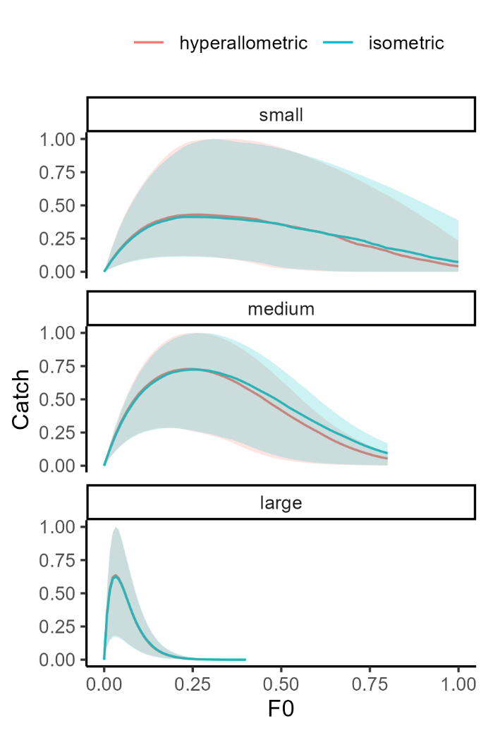

Figure 2: Catch (normalized) as a function of fishing mortality for the three species. Line and fill color is hyperallometric and isometric egg production. Shading shows the 95th and 5 percentile from 500 runs.